FROM: "WORLD ENTERPRISE MAGAZINE, AUGUST 2007"

Bright Brains
Games and puzzles to stretch the mind may have been around for centuries, but a 10-year-old Israeli company is making huge inroads into popularising hundreds of brainteasers that are captivating players around the world.

Dilemma Games Ltd produces more than 300 different types of wooden puzzles and complex brainteasers that general manager and CEO Shlomi Bar-Lev claims encourage thinking outside of the box." The main concept behind our games is to release the mind from fixed thinking patterns" he explains. "In so doing, our puzzles can help improve mathematical and topological abilities as well as enhance creative thinking, strategic planning and sensorimotor-cognitive and coordinating abilities."

With the games running the gamut from easy to extremely tough, Bar-Lev claims they are suitable for any age from toddlers to grownups and any IQ level."Our products are more than just simple games as they also help users to think diagonally in a process that can be applied to real-life problems" says Bar-Lev, adding that he believes his company offers the largest variety of such brainteasers in the world.

Products from Dilemma Games fall into two categories: the educational range and the entertainment range. "For our educational games, we have developed a specific curriculum syllabus and allied teacher training material" Bar-Lev describes. "The syllabus contains more than 100 different lessons and a teacher's manual on how to use the games as tools to develop intellectual and social skills."
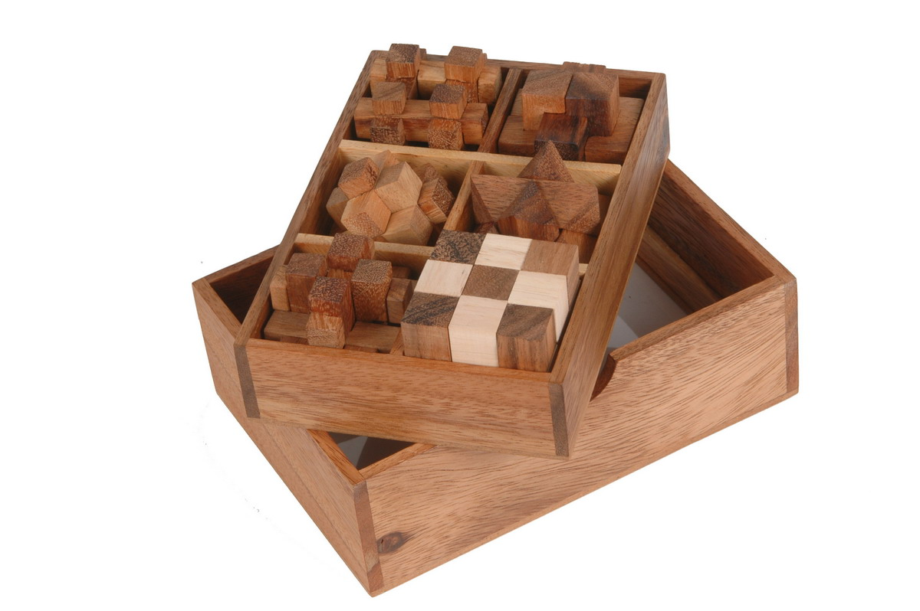

In one of the firm's markets - Korea - many schools has dedicated an hour a week to a period it calls Dilemma Games, and Bar-Lev notes: "One of our aims is to build these Thinking Centres in schools worldwide and to provide the puzzles, games and educational material for teachers to support this concept."

It is largely to achieve this goal that Dilemma Games prefers to appoint one distributor per country. "This way, we can train the distributor, who can pass that training on to interested educational facilities" Bar-Lev explains. "Currently, our products are sold in 48 countries worldwide and in about 20 of those we have appointed exclusive agents."
While Bar-Lev describes most of the company's games as educational, he stresses that they are also fun and "capable of captivating the mind for hours".
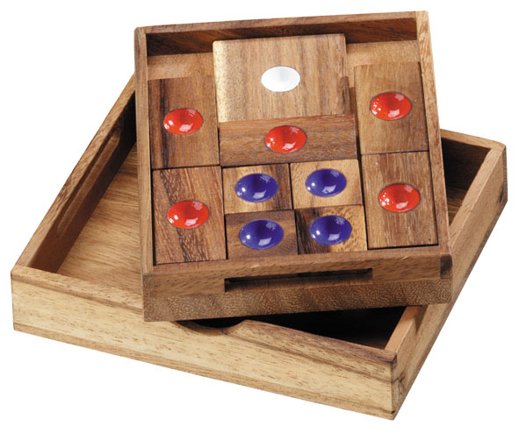

Such products fall into 12 families of games: interlocking puzzles, math games, pyramids, letter puzzles, brainteaser cubes, boxed games, ring-and-string puzzles, topological games, classic games, multi mix-and-match games, and the EduKiddy 3D puzzles and Gordian Knots lines.
"Our company started in 1996 with just 30 items, and we have added about five new items every three months" Bar-Lev claims. "During the couple of months between this year's Nuremburg Toy Fair and the Hong Kong Gifts & Premium Fair, for example, we added 10 new items."

Dilemma Games' wooden games and puzzles are made from the monkey pod tree from northern Thailand at the company's 70-worker factory in Chiang Mai. "The monkey pod is a small tree with very dry wood, which is ideal because it is plentiful and has a 13cm-wide trunk that can be cut to very precise dimensions" Bar-Lev explains.

The factory produces some 50,000 units per month and prices average around US$1.50 per game FOB Bangkok for a minimum order value of US$5,000-worth of assorted items.
In order to keep ahead of any ensuing competition, the company is constantly changing and developing its games. "Currently, our most popular item is Escape, which is a topological game of moving parts suitable for all ages" Bar-Lev explains. "Escape can provide 21 different games based on moving 10 flat pieces."

Another very popular puzzle is the Snake Cube, which comprises 27 cubes connected by rope and which challenges the player to bring the stretched snake back into a 3D cube. "Our set of 12 mini puzzles based on moving parts and topological strategies is also very popular" Bar-Lev insists.

International games fans are equally enthusiastic about the Kalaha set, which Bar-Lev say is based on an ancient African game that is claimed to be the oldest in the world. "This is a strategic game for two players who have to move marbles into the cashier slot" he explains.
Pento, a game of five black and five white squares on an 8x8 square board is also proving popular. "There are 15-20 lessons in our educational syllabus based on this game" he adds, saying that buyers at the Nuremberg Toy Fair were also very impressed with the Ring Puzzle, a game based on logic.

"The Sudoku craze has also created strong demand for our Sudoku board featuring 9x9 red-and-white squares, and our 16x16 Killer Sudoku board" Bar-Lev explains. We also have a simpler 4x4 Sudoku Kid and Sudoku Colours, which uses nine colours instead of numbers."
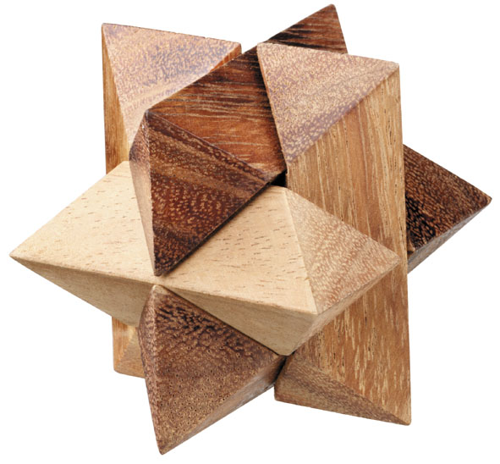

Dilemma Games' latest item is Wood's Dilemma, which requires the player to remove a golf ball seemingly firmly enclosed in a square wooden frame. "There are four wooden nails holding the frame in place and the solution is based on centrifugal force," Bar-Lev explains, noting that the game was "very well received" when it was launched at this year's Hong Kong Gifts & Premium Fair.
Topological games are particularly appealing to the gifts and premiums market for men, he says. He also describes adults as having two approaches towards the company's brainteasers. "The first is a continual process of trial and error to solve them, while the second is stepping back and examining conceptually how the puzzle might best be approached."

Whatever the tactic, Dilemma Games' products have proved highly popular in western and northern Europe, says Bar-Lev. "This is our biggest market and accounts for 65%-70% of our sales. TheUS and Asia, particularlyThailand and Korea, are also major markets," he adds.

Moving forward, Bar-Lev says the company also plans to tap the US market, with a strategy of exhibiting at the New York Toy Fairs and local shows, and is also eyeing Eastern Europe. "We are also interested in the Singaporemarket as parents there are extremely keen on maximising educational opportunities for their children," he adds.
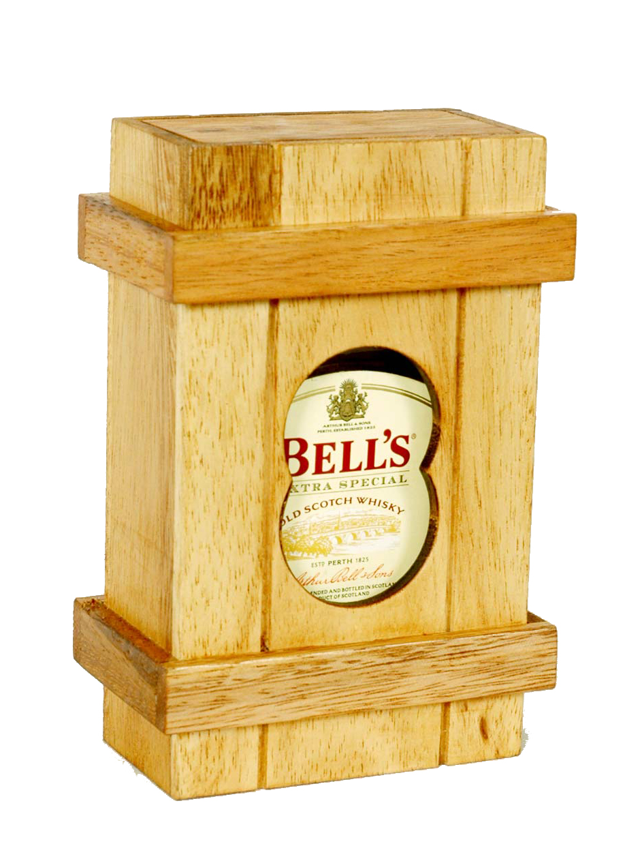
Meanwhile, business is booming for the company, with an annual growth of 40% for 2005/2006. This trend looks set to continue as Dilemma Games has boosted its marketing efforts by exhibiting at 14 international trade shows in the past two years.

In addition, the company hopes to expand its current small range of metal puzzles into a much larger business. "In 2006, we formed a joint-venture partnership with a mainland Chinese company that manufactures all of our metal puzzles," reveals Bar-Lev.

The Chinese company provides the manufacturing expertise and facilities, while Dilemma Games will provide more than 100 puzzle designs. "We are the sole distributor of these metal puzzles and, as well as offering the expertise in puzzles and games, we have a huge customer base which we can utilize," he adds.
Ultimately, says Bar-Lev, the company's long-term goal is simple: "We plan to remain in wooden games and puzzles, expand into metal games and appoint sole distributors in all our markets."
When it comes to expanding business, Dilemma Games appears to have come up with its own winning solution.

WRITTEN BY SANDRA JENNER
Breakout:
"We plan to remain in wooden games and puzzles, expand into metal games and appoint sole distributors in all our markets"

